FILE SHARING PLATFORM
@CREATIVITY THINK (9483175986/7019689991)

ABSTRACT:
The File Sharing Platform is a secure web-based system designed to enable seamless uploading, downloading, and sharing of files with fine-grained permission controls. Users can log in, upload documents, generate shareable links or send files via email, and track usage through dashboard analytics. Administrators manage users, moderate uploaded content, and analyze access patterns for security and performance monitoring. Built with Django and Django Rest Framework on the backend and React with Redux and Dropzone on the frontend, this platform ensures reliability, scalability, and efficient file handling suitable for teams, schools, and organizations..

INTRODUCTION OF THE PROJECT:
In modern collaborative environments, efficient and secure file sharing is essential for productivity. The File Sharing Platform provides a centralized solution that allows users to upload, share, and manage files with configurable permissions. It includes real-time dashboards, link-based sharing, and detailed usage statistics to support both individual and organizational workflows. The system uses Django for backend processing and React for the interactive frontend, ensuring smooth operations and a responsive user experience. This project is ideal for teams, educational institutions, and organizations that require structured document distribution with accountability and security..

PROJECT OBJECTIVES:

• To provide a user-friendly platform for secure file uploading and downloading
• To enable link-based and email-based file sharing
• To allow users to set and manage permissions for shared files
• To generate dashboard analytics for tracking usage and access
• To support administrators in monitoring content and managing users
• To ensure secure authentication and controlled file access

PROBLEM OF THE STATEMENT:
Traditional file sharing methods like email attachments, USB drives, and fragmented cloud storage result in inefficiencies, lack of permission control, and potential data breaches. Organizations need a centralized system where files can be securely uploaded, shared with controlled access, and monitored through usage analytics. The File Sharing Platform addresses these challenges by providing a secure, permission-based interface backed by real-time analytics and administrative monitoring tools. This reduces unauthorized access, improves collaboration efficiency, and ensures reliable document distribution..

MOTIVATION OF THE PROJECT:
• Need for secure and controlled file sharing
• Increasing demand for cloud-based collaboration tools
• Requirement for centralized dashboard analytics
• Need to eliminate fragmented sharing methods
• Demand for admin moderation and traceability

BLOCK DAIGRAM OF PROJECT:

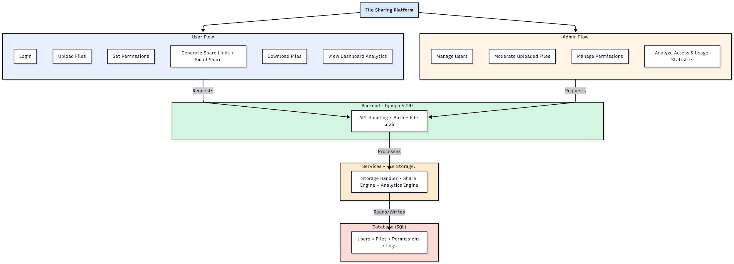

WORKING OF THE PROJECT:
Users begin by logging into the platform and uploading their files through a drag-and-drop interface. They can apply permission settings, generate shareable links, or send files directly via email. Each interaction is tracked and reflected in the user dashboard. The backend handles authentication, file processing, storage operations, and permission validation, while services manage sharing, analytics, and file logs. Administrators oversee file moderation, user management, and access monitoring, ensuring the platform remains secure and compliant. The system ensures efficient, organized, and secure file sharing for all users..

SOFTWARE REQUIREMENT:
- Backend:
  - Python 3.x
  - Django
  - Django REST Framework
  - SQLite/PostgreSQL
- Frontend:
  - Node.js and npm
  - React.js
  - Axios
- Development Tools:
  - Visual Studio Code
  - Postman (for testing APIs)
  - Git/GitHub (for version control)
- Server/Deployment (Optional):
  - Gunicorn, Nginx, or Heroku/AWS for hosting

ADVANTAGES OF THE PROJECT:

• Secure file sharing with permission controls
• Easy upload with drag-and-drop interface
• Share via link or email instantly
• Dashboard analytics for usage statistics
• Admin moderation to prevent misuse
• Centralized storage and organized access
• Faster collaboration across teams
• Accessible from any device via browser

APPLICATIONS OF THE PROJECT:
• Team collaboration platforms
• Schools and educational institutions
• Corporate document distribution
• Government or office file handling
• Freelancers sharing documents with clients
• Content moderation systems
• Secure cloud storage services
• Project-based file submission systems

REFERENCES:

- Django REST Framework Documentation — Django Software Foundation. Django Documentation. Available: https://docs.djangoproject.com/
- Django REST Framework. DRF Documentation. Available: https://www.django-rest-framework.org/
- React. React Official Documentation. Available: https://reactjs.org/docs/getting-started.html
- Redux. Redux Documentation. Available: https://redux.js.org/introduction/getting-started
- PostgreSQL Global Development Group. PostgreSQL Documentation. Available: https://www.postgresql.org/docs/
- MySQL. MySQL Reference Manual. Available: https://dev.mysql.com/doc/
- Git. Git Documentation. Available: https://git-scm.com/doc
- Node.js. Node.js Documentation. Available: https://nodejs.org/en/docs/
- Axios. Axios Documentation. Available: https://axios-http.com/docs/intro
- Socket.io Documentation – https://socket.io/docs/

